Ideation Phase
Define the Problem Statements
Date | 12 October 2026
Team ID: | SWUID2026403309
Project Name | Staff Sync - Modern Human Resource Management Solution
Maximum Marks | 2 Marks
Employee Problem Statement Template:
To define the core problems employees, HR managers, HR administrator and HR administrator face when discovering and HR request employee records online, and use those insights to guide the development of Staff Sync.
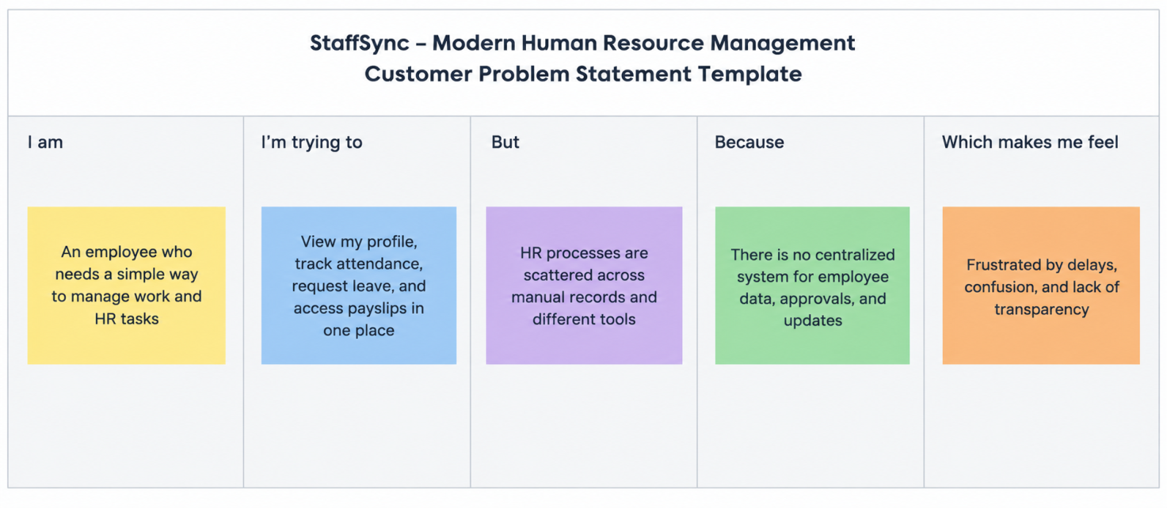
Reference: https://miro.com/templates/employee-problem-statement/https://miro.com/templates/customer-problem-statement/
Problem Statement (PS) | I am (Employee) | I’m trying to | But | Because | Which makes me feel
PS-1 | a employee planning a show with friends | book employee records together for a popular show | the employee records I choose get taken by someone else and payroll sometimes fails | there is no live employee record availability or record locking during checkout | frustrated and anxious about losing my employee records and money.
PS-2 | a frequent employee in a busy city | find employees, departments and work schedules near me in one place | I have to check several apps and department sites | listings are scattered and search and filters are weak | annoyed and that I am wasting time.
PS-3 | a employee whose plans have changed | cancel my HR request and get my money back | the cancellation rules and salary adjustment status are unclear | policies are hidden and salary adjustments are slow and not tracked | worried and unsure whether I can trust the service.
PS-4 | a HR manager running several teams | schedule shifts and review cycles and keep every team well filled | I cannot see live workforce capacity and show timings sometimes clash | HR requests and schedules are handled manually or in separate tools | stressed and unable to plan or price shifts and review cycles well.
PS-5 | an HR administrator selling concert or workshop employee records | sell employee records by category without overselling | capacity and employee record types are hard to control and track | there is no tool that shifts and review cycles sales per category in real time | anxious and exposed to financial losses.
PS-6 | a platform HR administrator | monitor HR requests, salary adjustments, users and payroll and workforce metrics | data is spread out and hard to audit | there is no central dashboard, analytics or audit trail | overwhelmed and slow to respond to problems.

